*“Heaven’s Light is Our Guide”*



Rajshahi University of Engineering & Technology

Department of Computer Science & Engineering

# Lab Report

Course Code: CSE 2206

Course Title: Microprocessors, Microcontrollers and

Assembly Language Sessional

Experiment No: 09

Experiment Name: Implementation of array and addressing mode.

|  |  |
| --- | --- |
| Submitted By-  Name : Sajidur Rahman Tarafder  Department : CSE  Roll No : 2003154  Section : C  Session:2020-21 | Submitted To-  Mohiuddin Ahmed  Lecturer  Department of CSE,  Rajshahi University of  Engineering and Technology, Rajshahi |

Task-1: Find the minimum and maximum element of a

given array.

Source Code:

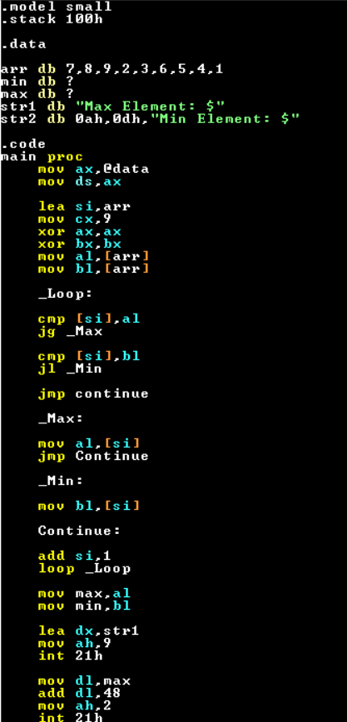

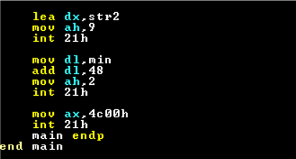

Output:

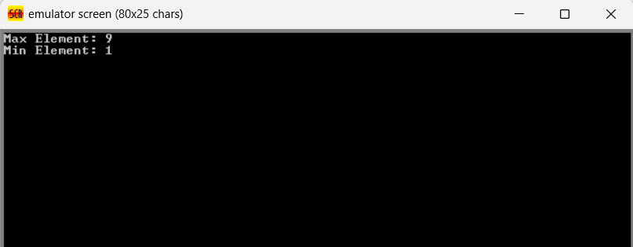

Discussion:

This assembly code aims to find the maximum and minimum elements in an array. It initializes variables for max and min, then iterates through the array elements, comparing each element to update the max and min values accordingly. After finding both values, it displays them using DOS interrupts. The code uses a simple linear comparison technique to determine the max and min elements, storing them in memory and outputting the results.

Task-2: Update all the elements of row 3 and column 3 of a

given 2D array to zero(0) and display the array.

Source Code:

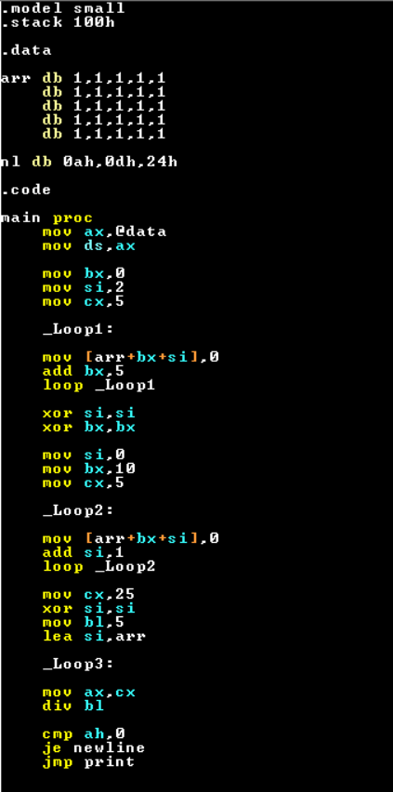

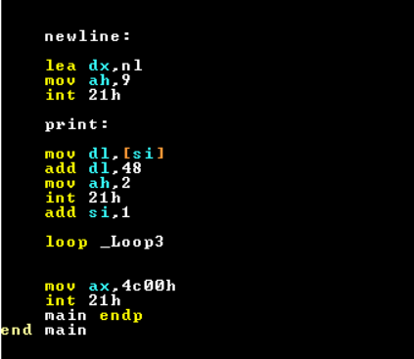

Output:

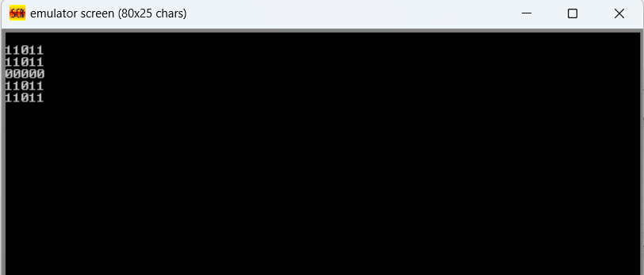

Discussion:

This assembly code initializes a 5x5 array with '1's, then sets every third element in each row and column to '0'. It utilizes loops and conditional checks to achieve this. Afterwards, it prints the resulting array in a grid format, converting the values to ASCII characters for display. Here based-indexed addressing mode is used to iterate through the array elements. The code uses nested loops to iterate through the array elements, checking for row and column boundaries, and prints the array with newline characters after each row. Overall, it's a program that modifies and displays a matrix-like structure in assembly language.